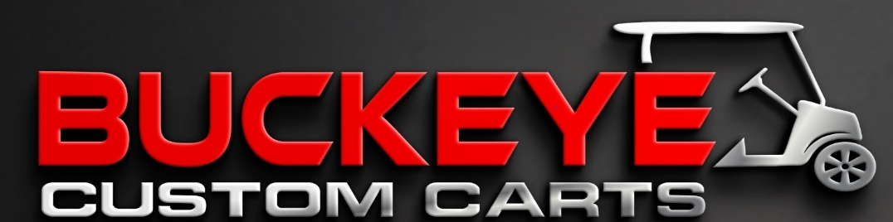
2025 YAMAHA DR2 – FUEL INJECTED

- CORAL RED BODY KIT
- STREET LEGAL LIGHT KIT
- CLEAR FOLD DOWN WINDSHIELD
- SIDE MIRRORS
- CUSTOM BLACK W/ RED PIPED SEATS
- REAR FLIP SEAT
- FENDER FLARES
- BRUSHGUARD
- DASH W/ LOCK BOXES
- 12” BLACK W/ BRUSHED ALUMINUM RIMS W/ STREET TIRES
- SAFETY BAR
- BLACK EXTENDED ROOF
- 2” WHEEL SPACERS ON ALL TIRES
- FUEL INJECTED
$8,499

FINANCING AVAILABLE
6 MONTH WARRANTY

